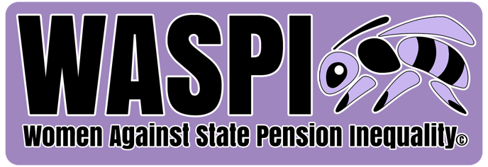

Women Against State Pension Inequality (WASPI) Briefing - 10 February 2025

Context

• In March 2024, the PHSO’s Stage 2 & 3 report found clear maladministration in the way the DWP communicated State Pension Age changes

• The PHSO took the extremely rare step of instructing Parliament to ensure the Government issues compensation and an apology as soon as possible to those affected

o The PHSO recommended Level 4 (£1,250-£2,950) compensation

o However, in December 2024, while an apology was delivered, the DWP refused to compensate 1950s-born women

• More than 200 MPs have publicly criticised the Government’s failure to deliver compensation so far, including 50 Labour MPs. At least 80 Ministers have also previously pledged in their support.

The PHSO’s conclusions

• The Deputy Ombudsman told the Work and Pensions Select Committee in January 2025 that during the time of maladministration, the DWP themselves conclude it should send targeted information to all 1950s-born women

o This finding was their own – it was not imposed on them, and they made this decision based on the statistics and data they had at the time

o However, while the DWP decided it was going to communicate via letters, they delayed sending them – this was maladministration and what 1950s-born women should be compensated for

• The PHSO’s findings are universal – everyone woman born in the 1950s suffered in some way due to the DWP’s maladministration and so they should be compensated

o Some women did of course find out about changes to their State Pension age (without the help of the DWP), but this should not preclude compensation for all those affected

• Financial constraints should not be a barrier to compensation

o The Treasury has saved some £200bn through changes to women’s State Pension age

o To ignore the PHSO sets a dangerous precedent as the role of independent ombudsmen is to ensure there are effective checks and balances on government

o This now leaves the door open for private companies to ignore the decisions of the ombudsmen e.g. banks with financial ombudsmen if they find their conclusions inconvenient

• It is not ‘right and fair’ for MPs to turn their backs despite previously making promises to support WASPI compensation, once again eroding public trust

The DWP’s response
• The DWP are using 2014 statistics which found that the majority of people do not recall received unsolicited mail. However, it does not correlate with what the DWP decided in 2005

o Furthermore, letters are not the only form of communication available to the DWP but 1950s-born women required specific, targeted information at that time, to improve awareness levels

o It was following the letters sent between 2009 and 2013 that the campaign against the injustices facing 1950s-born women began

▪ Women received between one and seven years’ notice of the significant increases to their State Pension age – they had lost opportunities to make decisions

• The DWP maintains that most women knew about changes to their State Pension age. However, there was incorrect information on the DWP’s website until 2016 which said women’s retirement age was 60

o The surveys quoted by the DWP do not refer to individual women’s understanding of the impact of State Pension age changes on them – but rather a general awareness of future changes to the population as a whole

o The very low levels of women born in the 1950s surveyed (c. 200) also cannot be used to determine the views of more than 3.8 million women across the country

o Elsewhere within the PHSO’s report, research found that only 43% of all women affected by the changes knew their State Pension age was 65, or between 60 and 65 years

• In statements since the DWP’s announcement, ministers have said on multiple occasions that women experienced “no financial loss”.

o This is not correct. The PHSO found no direct financial loss. This is a category of loss that means affected women lost no entitlement which WASPI agrees with, as this refers to the change in the law. Instead, women lost the opportunity to make informed decisions which led to significant financial loss in some cases

▪ This is called material loss by the PHSO, because it is not direct. Regardless of what it iscalled, many 1950s-born women have suffered as a result

What Parliament can do now

• WASPI is calling for the Government to fully implement the PHSO’s report

o WASPI will continue to take all actions necessary to help 1950s-born women achieve
compensation but only Parliament can help make this happen

• The DWP is currently the perpetrator, judge, jury and sentencer in their own maladministration – the PHSO has instructed MPs to hold them to account and ensure justice is delivered

• WASPI are launching an interactive MP supporters map which will be updated in the weeks ahead and available for the public

Latest WASPI women statistics

• Polling carried out in January 2025 of 2,000 UK adults found:
o 74% of the public back compensation for WASPI women
o 76% of the public say all MPs should be given a vote in Parliament on compensation
o 75% of the public say the Government should always accept the findings of the Ombudsman
• A survey of 11,000 WASPI women carried out in winter 2024 found:
o 84% of WASPI women said they worry about the ongoing high cost of energy bills
o 76% of WASPI women said they worry about the future of their finances
o 71% of WASPI women reported they avoid leaving the house to save money

• More than 300,000 WASPI women have died since the campaign began. Another dies every 13 minutes.

About WASPI

WASPI calls for a one-off payment from the Government as fair and fast compensation for the lack of notice affected women received over State Pension age increases. This resulted in serious financial losses, and sustained damage to their mental health and wellbeing.

WASPI does NOT campaign for the retirement age for women to return to 60, nor does it take issue with the law change itself.

For further information, please contact waspicomms@gmail.com

